**Some utilities**

Methods are functions which are specifically written for particular class. we saw how to get the methods that go with a particular class. Now there are more modern, less clunky ways for this.

**See which methods are available per class**

Have a look at the sloop package, maintained by Hadley Wickham (that alone is a reason). Use the function s3_methods_generic to get a nice table with some relevant information:

# install.packages("sloop")

library(sloop)

citation("sloop")

s3_methods_generic("mean")

# s3_methods_generic("as.data.frame")

# A tibble: 10 x 4

generic class visible source

1 mean Date TRUE base

2 mean default TRUE base

3 mean difftime TRUE base

4 mean POSIXct TRUE base

5 mean POSIXlt TRUE base

6 mean quosure FALSE registered S3method

7 mean vctrs_vctr FALSE registered S3method

8 mean yearmon FALSE registered S3method

9 mean yearqtr FALSE registered S3method

10 mean zoo FALSE registered S3method

You can use the above to check if there exists a method for the class you are working with. If there is, you can help R by specifying that method directly. Do that and you gain, sometimes meaningfully so, a speed advantage. Let’s see how it works in couple of toy cases. One with a Date class and one with a numeric class.

library(magrittr) # for the piping operator

# install.packages("scales") # we talk about this shortly

library(scales)

# install.packages("microbenchmark")

library(microbenchmark)

citation("microbenchmark")

# Create a sequence of dates

some_dates <- seq(as.Date("2000/1/1"), by = "month", length.out = 60)

bench <- microbenchmark(mean(some_dates),

mean.Date(some_dates), times = 10^3) %>% summary

print(bench)

expr min lq mean median uq max neval

1 mean(some_dates) 6.038 6.642 7.011879 6.642 6.944 14.189 1000

2 mean.Date(some_dates) 4.528 4.831 5.417070 5.133 5.435 51.923 1000

cat("Save", (1 - bench$mean[2] / bench$mean[1]) %>% percent(digits = 2))

Save 23%

# Now something more standard

x <- runif(1000) # simulate 1000 from random uniform

bench <- microbenchmark( mean(x), mean.default(x) )

print(bench)

expr min lq mean median uq max neval

1 mean(x) 4.529 5.133 7.113611 7.548 8.453 44.376 1000

2 mean.default(x) 2.113 2.416 3.148788 3.321 3.623 9.963 1000

> cat("Save", (1 - bench$mean[2] / bench$mean[1]) %>% percent(digits = 2))

Save 56%

Specifying the exact method (if it is there) also reduces the variance around computational time, which is important for simulation exercises:  
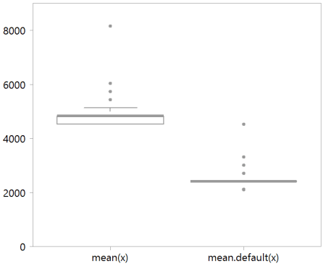

**Percent formatting**

In the code snippet above I used the scales package’s percent function, which spares the formatting annoyance.

**Get your object’s size**

When I load a data, I often want to know how big is it. There is the basic object.size function but it’s ummm, ugly. Use the aptly named object_size function from the pryr package.

library(pryr)

citation("pryr")

> x <- runif(10^3)

> object_size(x)

8.05 kB

> object.size(x)

8048 bytes

> x <- runif(10^6)

> object_size(x)

8 MB

> object.size(x)

8000048 bytes

> x <- runif(10^8)

> object_size(x)

800 MB

> object.size(x)

800000048 bytes # is this Mega or Giga?

> x <- runif(10^9)

> object_size(x)

8 GB

> object.size(x)

8000000048 bytes # is this Mega or Giga?

**Memory management**

Use the gc function; gc stands for garbage collection. It frees up memory by, well, collecting garbage objects from your workspace and trashing them. I at least, need to do this often.

**heta function**

I use the head and tail functions a lot, often as the first thing I do. Just eyeballing few lines helps to get a feel for the data. Default printing parameter for those function is 6 (lines) which is too much in my opinion. Also, especially with time series data you have a bunch of missing values at the start, or at the end of the time frame. So that I don’t need to run each time two function separately, I combined them into one:

heta <- function(x, k= 3){

cat("Head -- ","\n", "~~~~~", "\n")

print(head(x, k))

cat("Tail -- ","\n", "~~~~~", "\n")

print(tail(x, k))

}

**Sound the alarm**

If you stretch your model enough, you will have to wait until computation is done with. It is nice to get a sound notification for when you can continue working. A terrific way to do that is using the beepr package.  
  
# install.packages("beepr")  
library(beepr)  
citation("beepr")  
for (i in 0:forever){  
do many tiny calculations and don't ever converge  
}  
beep(4)